Bill Prediction & Power Factor Measuring With SMS Alert

Industries use many electrical equipment to get their work done. It becomes difficult for them to understand which equipment is consuming more electricity and which one is efficient enough. Good quality equipment consume less electricity and also give a good power factor in usage. These facts can be evaluated and also be automated using this project.
This project is based on ATmega family microcontroller. The energy meter connected to the system helps to monitor the consumption of loads connected in the system. With the help of this, the system can measure the power being consumed for a fixed interval of time. From this information we can set into the system to give us the information about how much the particular device will consume at this rate for continuous x number of hours or x number of days. This was about measurement of energy consumption. In the system we have a connection over which power factor measurement is also available. Over this connection, devices that usually give poor power factor like motor can be connected to measure its power factor. The more the power factor approaches 1, the better the device is in its performance. There are 4 load connections in the system over which bulbs can be connected or any other AC Mains Voltage appliance. These loads can be switched using slide switches given on board of the project or also through SMS. SMS is received by GSM module and sent to the controller for processing. In this way automation is also achieved in this project.
In this way this project can prove to be very useful for places where devices are needed to be quality checked before they can actually be used or deployed on site. The factors being measured by this project are the power consumption rate, power factor and automatic control of the loads connected to the system.

Block Diagram :
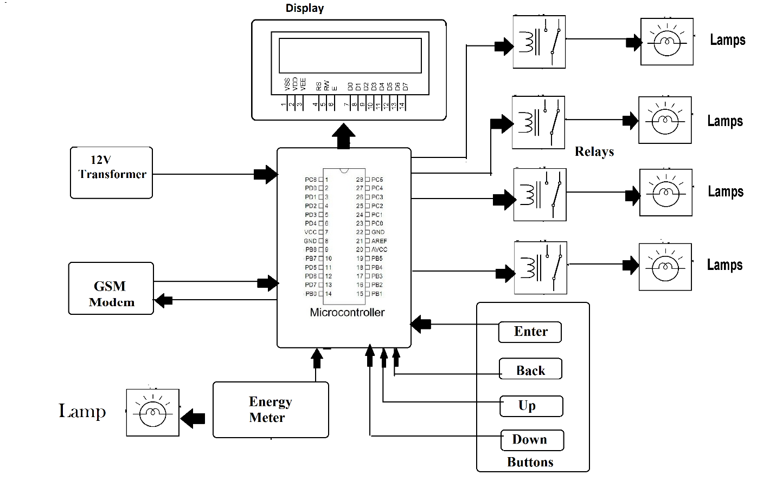

Hardware Specifications :
- LCD Display
- 12V Transformer
- GSM Modem
- Lamps
- Relays
- Atmega Microcontroller
- Current Sensor
- Capacitors
- Resistors
- Diodes
- Connectors

Software Specifications :
- Arduino ide
- MC Programming Language: C

